**Tracking radar targets with multiple reflection points**

**Rev 1.0**

Texas Instruments, Incorporated  
20450 Century Boulevard  
Germantown, MD 20874 USA



**Version History**

|  |  |  |
| --- | --- | --- |
| **Date** | **Owner** | **Comment** |
| **April 13, 2017** | **Michael Livshitz** | **Initial version** |
| **July 20, 2017** |  | **Version 1.0** |
| **Nov 17, 2017** |  | **Version 1.1**   * **Updated group and centroid covariance matrices calculation**   **Updated configuration and added advanced configuration parameters** |
| **Feb 6, 2018** |  | **Version 1.2**  **Updated configuration parameters description** |
| **March 9, 2018** |  | **Version 1.3**  **Added derivations for tracking in 3D space** |
| **September 6, 2018** |  | **Version 1.4**  **Added description of 3D or 2D library options**  **Changes in configuration parameters to support 3D and 2D options** |
| **October 18, 2018** |  | **Version 1.5**  **Changed Gating function from constant volume to constant gain with limiters.** |
| **March 16, 2023** | **Radha Agarwal** | **Version 1.6**  **Updated memory requirements for 2D and 3D Space Tracker** |

Table of Contents

1. Introduction 5

1.1. Tracking Module 5

1.2. Radar Geometry 6

1.3. Choice of Tracking Coordinate System 7

1.4. 2D Space Geometry 7

1.5. 2D Space, Constant Velocity Model 7

1.6. 2D Space, Constant Acceleration Model 10

1.7. 3D Space, Geometry 11

1.8. 3D Space, Constant Velocity Model (3DV) and Constant Acceleration (3DA) models 12

2. Kalman Filter Operations 15

2.1. Prediction Step 15

2.2. Update Step 15

2.3. Design of Process Noise Matrix 16

2.3.1. Continuous White Noise Model 16

2.3.2. Piecewise White Noise Model 17

3. Group Tracking 19

3.1. High Level Algorithm Design 19

3.2. Group Tracking Block Diagram 20

3.3. Prediction Step 20

3.4. Association Step 20

3.4.1. Gating Function 21

3.4.2. Scoring Function 21

3.5. Allocation Step 22

3.6. Updating Step 23

3.7. Maintenance Step 24

4. Implementation Details 25

4.2. Building and using the library 25

4.3. Configuration Parameters 26

4.3.1. Mandatory Configuration Parameters 26

4.3.2. Advanced parameters 26

4.4. Memory Requirements 30

4.4.1. 2D Space Tracker 30

4.4.2. 3D Space Tracker 31

5. Performance 33

5.1. Tracking Reliability 33

5.1.1. Test Case description 33

5.1.2. Results 35

5.2. Tracking Precision 37

5.2.1. Test Case description 38

5.2.2. Results 38

5.3. Tracking Resolution 38

5.3.1. Initial Separation Tests 38

5.3.2. Dynamic Separation Tests 39

6. References 39

7. Appendix 40

7.1. Evaluating Partial Derivatives for 2D space tracking 40

7.1.1. Evaluating range partial derivatives 40

7.1.2. Evaluating azimuth partial derivatives 40

7.1.1. Evaluating doppler partial derivatives 40

7.2. Evaluating Partial Derivatives for 3D space tracking 42

7.2.1. Evaluating range partial derivatives 42

7.2.2. Evaluating azimuth partial derivatives 42

7.2.1. Evaluating elevation partial derivatives 43

7.2.2. Evaluating Doppler partial derivatives 43

# Introduction

## Tracking Module

In Radar Processing stack, the tracking algorithms are the implementations of the localization processing Layer. Tracker is expected to work on the Detection layer inputs, and provide localization information to the classification layers.

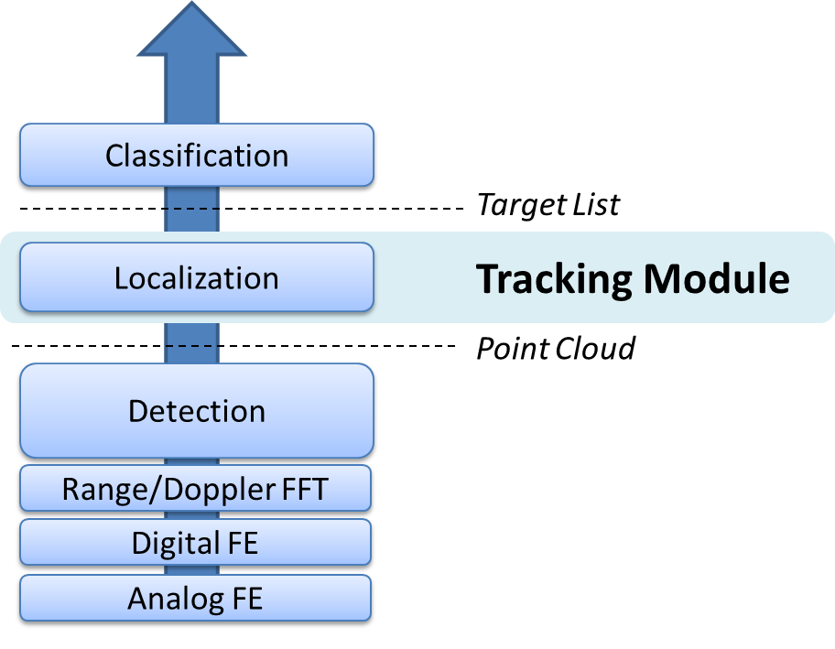

Figure . Radar Processing Layers

With high resolution Radar sensors, the detection layer is capable of sensing multiple reflections from real life targets, delivering a rich set of measurement vectors (in some cases, thousands of vectors per frame), known as a *Point Cloud*. Each measurement vector represents a reflection point, with Range, Azimuth, and Radial velocity. Each measurement vector may also contain reliability information.

Tracking Layer is expected to input the point cloud data, perform target localization, and report the results (a *Target List*) to a classification layer. Therefore, the output of the tracker is a set of trackable objects with certain properties (like position, velocity, physical dimensions, point density, and other features) that can be used by a classifier to make an identification decision.

## Radar Geometry

The picture below illustrates single reflection point at time n. Real life radar targets are represented by multiple reflection points. Each point is represented by range, angle, and radial velocity (range rate):

* Range *r,*
* Azimuth angle ,
* Radial velocity

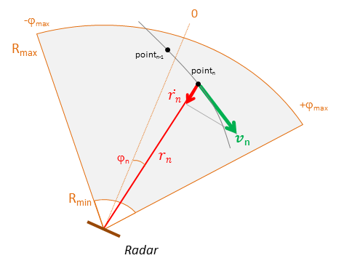

Figure . Radar Geometry in 2D

## Choice of Tracking Coordinate System

For convenience of target motion extrapolation, we chose tracking in Cartesian coordinates. This allows for simple Newtonian linear prediction models. We chose to keep measurement inputs in polar coordinates to avoid error coupling. We will use extended Kalman filter to linearize the dependencies between tracking states and measurement vector.

Tracking can operate in either 2D or 3D Cartesian spaces. For each space, we use either constant velocity model or constant acceleration model.

## 2D Space Geometry

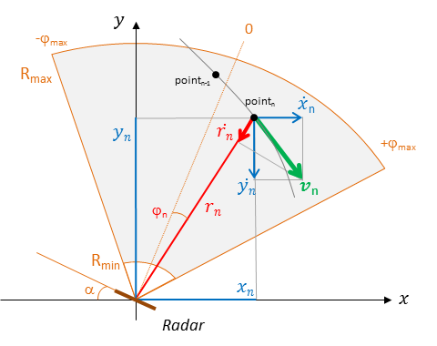

Figure . Tracking in 2D

The angular location coordinates are converted to Cartesian coordinates using

The objective is to track the location of the objects using the noisy measurements of range, angle, and Doppler (radial velocity)

## 2D Space, Constant Velocity Model

We use Kalman filter to “refine” the location estimates. The state of the Kalman filter at time instant *n* is defined as

(‑)

where the state vector is defined in Cartesian coordinates,

(1‑2)

is a transition matrix

(‑)

and is the vector of process noise with covariance matrix of size 4×4.

The input measurement vector includes range, angle and radial velocity

(1‑4)

The relationship between the state of the Kalman filter and measurement vector is expressed as:

(‑)

Where, is a measurement matrix,

(‑)

the function is defined as

(1‑7)

and is vector of measurement noise with covariance matrixof size 3×3.

In above formulation, the measurement vector is related to the state vector via a non-linear relation. Because of this, we use Extended Kalman filter (EKF), which simplifies the relation betweenandby retaining only the first term in the Taylor series expansion of.

(1‑8)

where, is a-priori estimation of state vector at time *n* based on *n-1* measurements,

(1‑9)

Calculating partial derivatives (see the Appendix below):

(1‑10)

## 2D Space, Constant Acceleration Model

For constant acceleration model, the state of the Kalman filter at time instant *n* is defined as

(‑)

where the state vector is defined in Cartesian coordinates,

(1‑12)

is a transition matrix

(1‑13)

andis the vector of process noise with covariance matrix of size 6×6.

The input measurement vector is the same as in constant velocity model, includes range, angle and radial velocity

. (1‑14)

The relationship between the state of the Kalman filter and measurement vector is expressed as:

(‑)

where

(1‑16)

To linearize state to measurement relations, we perform partial derivatives

(1‑17)

(1‑18)

## 3D Space, Geometry

In the picture below, sensor is positioned at the origin. Target trajectory is shown at times,, and . Target is moving with velocity vector. Measurement vector at time includes range, azimuth, elevation and radial velocity:

(1‑19)

State vector in Cartesian coordinates will be for constant velocity model, and for constant velocity model:

(1‑20)

(1‑21)

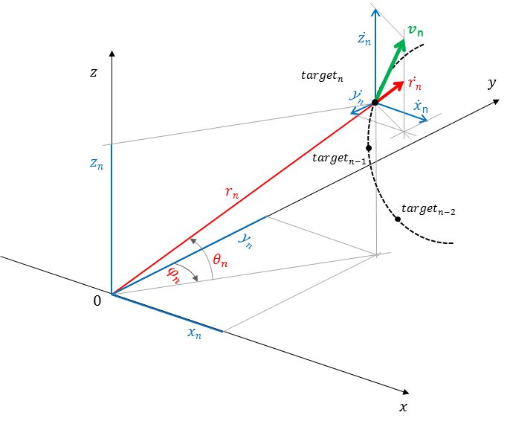

Figure . Tracking in 3D

## 3D Space, Constant Velocity Model (3DV) and Constant Acceleration (3DA) models

We use Kalman filter to “refine” the location estimates. The state of the Kalman filter at time instant *n* is defined as

(‑)

where the state vector is defined in Cartesian coordinates. For 3D space, we use or as defined in previous paragraph.

Transition matrix is

(‑)

or

(‑)

and is the vector of process noise with covariance matrix of size 6×6 or 9x9.

The input measurement vector includes range, azimuth, elevation, and radial velocity

(1‑25)

The relationship between the state of the Kalman filter and measurement vector is expressed as:

(‑)

Where, is a measurement matrix,

(‑)

the function is defined as

(1‑28)

and is vector of measurement noise with covariance matrixof size 4×4.

In above formulation, the measurement vector is related to the state vector via a non-linear relation. Because of this, we use Extended Kalman filter (EKF), which simplifies the relation betweenandby retaining only the first term in the Taylor series expansion of.

(1‑29)

where, is a-priori estimation of state vector at time *n* based on *n-1* measurements,

(1‑30)

Calculating partial derivatives (see the Appendix below):

(1‑31)

(1‑32)

# Kalman Filter Operations

The notation we use:

* – State vector of tracking object at time . Each tracking object has its own state vector, which is predicted and updated independently. For simplicity reasons we omit the tracking index.
* – A-priori (predicted) estimates of tracking state at time.
* – State vector estimation error covariance matrix at time , defined as Cov.
* – A-priory (predicted) estimates of state vector covariance matrix at time.

## Prediction Step

With available measurement until time instant *n*-1, the a *priori* state and error covariance estimates are obtained using:

(2‑1)(2‑2)

The above equations constitute the *prediction* step of the Kalman filter. is the process noise covariance matrix. See section 2.3 for the details.

In addition, we also compute using formula above.

## Update Step

As measurements at time instant become available, state and error covariance estimates are updated in the following measurement update procedure:

1. Compute innovation (or measurement residual)

(2‑3)

1. Compute innovation covariance

(2‑4)

1. Compute Kalman gain

(2‑5)

1. Compute a-posteriori state vector

(2‑6)

1. Compute a-posteriori error covariance

(2‑7)

## Design of Process Noise Matrix

This section is adopted from the works in [1].

The choice of is important for the behavior of the Kalman filter. If is too small then the filter will be overconfident in its prediction model and will diverge from the actual solution. If is too large than the filter will be too much influenced by the noise in the measurements and perform sub-optimally.

The kinematic system (a system that can be modeled using Newton's equations of motion) is continuous, i.e. their inputs and outputs can vary at any arbitrary point in time. However, Kalman filters used here are discrete. We sample the system at regular intervals. Therefore we must find the discrete representation for the noise term in the equation above. This depends on what assumptions we make about the behavior of the noise. We will consider two different models for the noise.

### Continuous White Noise Model

Let's say that we need to model the position, velocity, and acceleration. We can then assume that acceleration is constant for each discrete time step. Of course, there is process noise in the system and so the acceleration is not actually constant. The tracked object will alter the acceleration over time due to external, un-modeled forces. In this section we will assume that the acceleration changes by a continuous time zero-mean white noise.

Since the noise is changing continuously we will need to integrate to get the discrete noise for the discretization interval that we have chosen. We will not prove it here, but the equation for the discretization of the noise is

(2‑8)

where is the continuous noise. The general reasoning should be clear. is a projection of the continuous noise based on our process model at the instant . We want to know how much noise is added to the system over a discrete interval, so we integrate this expression over the interval [0,].

For the second order Newtonian system, the fundamental matrix is

(‑)

We now define the continuous noise as

(‑)

where is the spectral density of the white noise. This can be derived, but is beyond the scope for now. In practice we often do not know the spectral density of the noise, and so this turns into an "engineering" factor - a number we experimentally tune until our filter performs as we expect. We can see that the matrix that is multiplied by effectively assigns the power spectral density to the acceleration term. This makes sense; we assume that the system has constant acceleration except for the variations caused by noise. The noise alters the acceleration.

Computing the integral, we obtain

(2‑11)

Extrapolating back to 6 states,

(2‑12)

### Piecewise White Noise Model

Another model for the noise assumes that the that highest order term (say, acceleration) is constant for the duration of each time period, but differs for each time period, and each of these is uncorrelated between time periods. In other words there is a discontinuous jump in acceleration at each time step. This is subtly different than the model above, where we assumed that the last term had a continuously varying noisy signal applied to it.

We will model this as

(2‑13)

where is the noise gain of the system, and is the constant piecewise acceleration (or velocity, or jerk, etc).

For the second order system

(2‑14)

In one time period, the change in acceleration will be change in velocity will be, and change in position will be. This gives us

(2‑15)

The covariance of the process noise is then

(2‑16)

(2‑17)

It is not clear whether this model is more or less correct than the continuous model - both are approximations to what is happening to the actual object. Only experience and experiments can guide to the appropriate model. It is expected that either model provides reasonable results, but typically one will perform better than the other.

The advantage of the second model is that we can model the noise in terms of which we can describe in terms of the motion and the amount of error we expect. The first model requires us to specify the spectral density, which is not very intuitive, but it handles varying time samples much more easily since the noise is integrated across the time period. However, these are not fixed rules - use whichever model (or a model of your own devising) based on testing how the filter performs and/or your knowledge of the behavior of the physical model.

A good rule of thumb is to set 𝜎 somewhere from to, where is the maximum amount that the acceleration will change between sample periods. In practice we pick a number, run simulations on data, and choose a value that works well.

# Group Tracking

## High Level Algorithm Design

With advances in detection accuracy, the real world radar targets (cars, pedestrians, walls, landing ground, etc.) are presented to a tracking processing layer as a set of multiple reflection points. Those detection points form a group of correlated measurements with range, angle, and angular velocity. Of course, at any time there could be multiple real world targets. Therefore, we seek a tracker capable of working with multiple target groups.

The group tracking approach is illustrated in figure below.

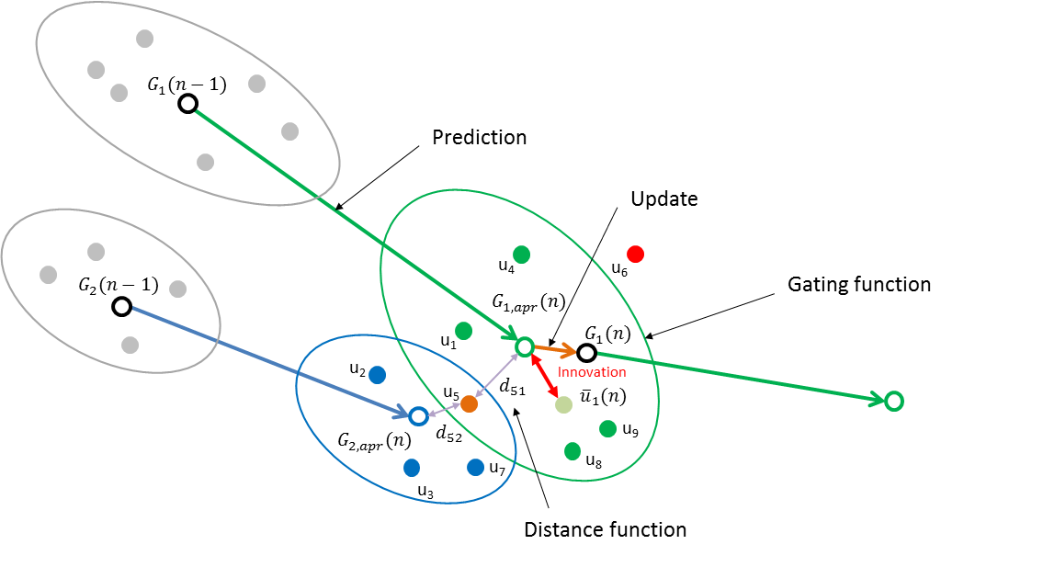

Figure . Group Tracking

## Group Tracking Block Diagram

The algorithm flows through the major steps shown in a block diagram and described below:

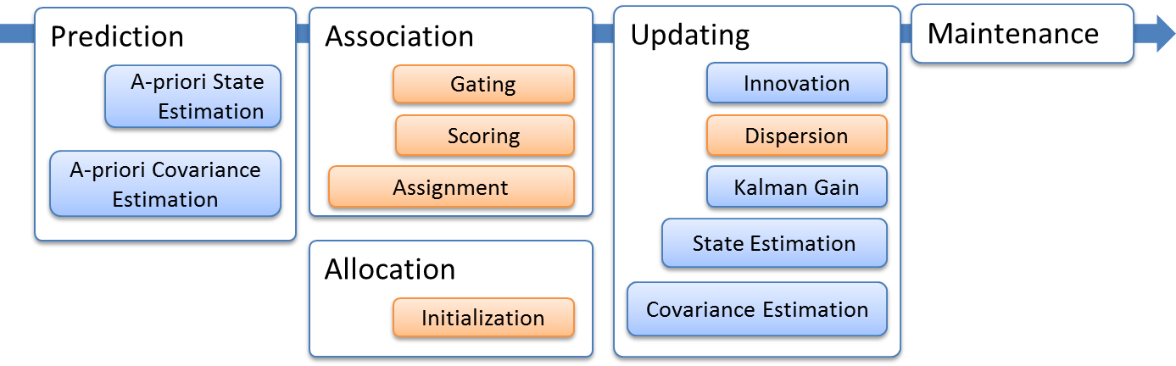

Figure . Tracking Block Diagram

The functions shown in blue are classical extended Kalman filter operations. The functions are shown in brown are additions to support multipoint grouping.

## Prediction Step

We use the Kalman filter prediction process to estimate tracking group centroid for time n based on state and process covariance matrices estimated at time n-1. We compute a-priori state and covariance estimations for each trackable object. At this step we also compute measurement vector estimations. See section 2.1 for details.

## Association Step

Assume existence of one or more tracks and the associated predicted state vector. For each given track we form a gate about the predicted centroid. The gate should account for a) target maneuver, for the dispersion of the group and for the measurement noise.

We use group residual covariance matrix to build an ellipsoid in 3D measurement space about the tracking group centroid. The ellipsoid will represent *a gating function* to qualify individual measurements we observe at time n. The gating function design is explained in the section below.

For the measurements within the gate, we compute *normalized distance function* as a cost function to associate a measurement to each track

The assignment process minimizes the cost function, assigning one measurement at a time to the closest track. This creates a set of measurements associated with each track

### Gating Function

The gating function represents the amount of innovations we are willing to accept given current state of uncertainty that exists in a current track.

To measure the amount of uncertainty, we define the group residual covariance matrix as

(‑)

Note that this group covariance matrix is between a member of the measurement group and the group centroid.

Compare group residual covariance with formula for individual target tracking.

The termrepresents the uncertainty in the centroid due to target maneuvering, and is similar to the term used for individual target tracking.

The term is the measurement error covariance matrix. Since we are building a gate in measurements coordinates, we don’t need any transformation.

Finally, the term is the estimation of group track dispersion matrix.

For each existing track, for all measurement vectors we obtained at time we define a distance function, which represents the amount of innovation the new measurement adds to an existing track.

(3‑2)

(3‑3)

We define the chi-squared test (because the sum of squares of M Gaussian random variables with zero mean is chi-square distribution with degree of freedom M) limits the amount of innovation we are willing to accept as

(3‑4)

The boundary condition represents arbitrarily oriented ellipsoid centered at a-priory expectation of the measurement vector, while represents the largest normalized distance from to the measurement that we are going to accept into the group. To avoid stability issues with constant gain approach (the bubble captures new points, grows, which increases the chances to capture more points), we add a limiting factor. Under no circumstances the targets can capture points further than pre-configured limits.

### Scoring Function

The picture below illustrates the post gating situation, where measurement vectors pass the gating test for the green track, while vectors pass the gating test for the blue track.

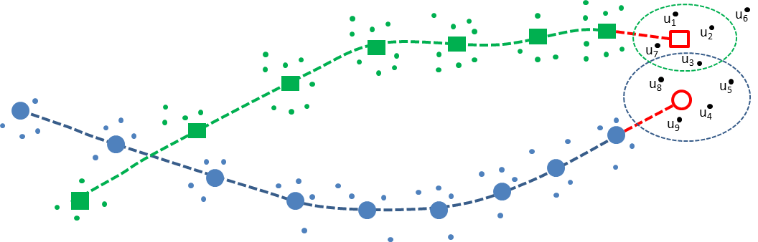

Figure . Scoring function Illustration

As shown in [2], the likelihood function (assuming Gaussian distribution for the residual) associated with assignment of observation j to track I is

(3‑5)

Where, is determinant of the residual covariance matrix for track,, and is residual vector from observation to track .

To maximize the, by taking the logarithm, we derive the scoring criteria we want to minimize:

(3‑6)

## Allocation Step

For measurements not associated with any track (that are outside of any existing gate), new group tracker is allocated and initialized. This is an iterative process, similar to DBSCAN clustering algorithm. It is significantly simpler, since it is only done for the leftover measurements.

We first select a leading measurement and set a centroid (range/angle) equal to it. The leading point’s radial velocity is used to unroll other candidate’s radial velocities. One candidate at a time we first check whether the point is within velocity bounds (velocity check, followed by a distance check. If passed, the centroid is recalculated, and point is added to the cluster. Once finished, we perform the few qualifying tests for cluster. We may need to see minimal number of measurements, strong enough combined SNR, and/or minimal amount of dynamicity of the centroid. If passed, we create (allocate) a new tracking object and use the associated points to initialize dispersion matrices. Clusters with fewer points are ignored.

## Updating Step

This process is similar to the steps described in 2.2. Below we only outline the differences.

Tracks are updated based on the set of associated measurements computed at association step. For each track, we first compute which is mean of all associated measurements.

Then, we compute the amount of innovation using the mean of all measurements associated with it:

(3‑7)

Then, we compute residual centroid covariance matrix:

(3‑8)

where is a measurement noise covariance matrix, computed as below:

(3‑9)

where,

is the estimation of group track dispersion matrix,

is the number of measurements associated with given track,

is the estimated number of elements in target tracked by the given track,

is a weighting factor that is a function of the number of observations and estimated number of elements in the target.

From the equation above, measurement noise covariance matrix is the sum of two factors. The first term represents the error in measuring the centroid due to radar measurement error and is decreased by the number of the measurements associated with tracking centroid. The second term represents the uncertainty due to the fact that not all the elements may have been observed. We define the weighting factor for the case with no false detections () as:

(3‑10)

Note the limits on this function: when all elements are detected and when we received single associated measurement.

We take as a configuration parameter, and estimate recursively as described below.

For the measurement vector, the dispersion matrix is

(3‑11)

Where, and, and are means computed for a given group of measurements in a standard manner.

(3‑12)

Once is computed, the rest steps (computing the Kalman gain, state and covariance matrices) are identical to in 2.2.

## Maintenance Step

Each track goes through a life cycle of events. At maintenance step we may decide to change the state or to delete the track that is not used any more.

# Implementation Details

* 1. Group Tracker

Tracking algorithm is implemented as a library. Application task creates an algorithm instance with configuration parameters that describe sensor, scenery, and behavior of radar targets. Algorithm is called once per frame from Application Task context. It is possible to create multiple instances of group tracker.

The figure below explains the steps algorithm goes during each frame call. Algorithm inputs measurement data in Polar coordinates (range, angle, Doppler), and tracks objects in Cartesian space. Therefore we use Extended Kalman Filter (EKF) process.

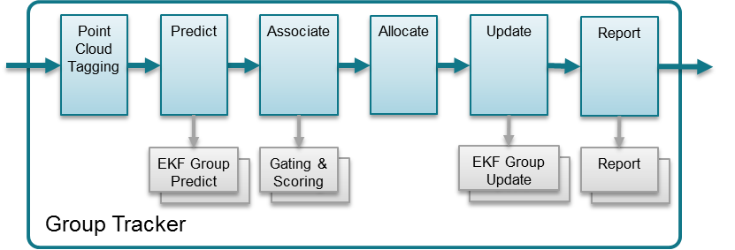

Figure . Group Tracking Algorithm

Point cloud input is first tagged based on scene boundaries. Some points may be get tagged as “outside the boundaries”, and will be ignored in association and allocation processes.

Predict function estimates tracking group centroid for time n based on state and process covariance matrices estimated at time n-1. We compute a-priori state and error covariance estimations for each trackable object. At this step we also compute measurement vector estimations.

Association function allows each tracking unit to indicate whether each measurement point is “close enough” (gating), and if it is, to provide the bidding value (scoring). Point is assigned to a highest bidder.

Points not assigned, are going through an Allocate function. During the Allocation process, points are first joined into a sets based on their proximity in measurement coordinates. Each set becomes a candidate for allocation decision. It has to pass multiple tests to become a new track. Once passed, the new tracking unit is allocated.

During Update step, tracks are updated based on the set of associated points. We compute the innovation, Kalman gain, and a-posteriori state vector and error covariance. In addition to classic EKF, the error covariance calculation includes group dispersion in measurement noise covariance matrix.

The Report function queries each tracking unit and produces the algorithm output.

## Building and using the library

The algorithm is delivered as a source code with ready-to-build makefile infrastructure. Library can be built to support either 2D or 3D geometries. Application is expected to include the library (2D or 3D) as it needs. The configuration is passed to the algorithm instance at module create time. The configuration parameters are described in the below chapter. Recommended values for Traffic monitoring (TM) and People counting (PC) use cases are given as an example. Changes from previous document version are highlighted in red.

## Configuration Parameters

The configuration parameters are used to configure Tracking algorithm. They shall be adjusted to match customer use case based on particular scenery and targets characteristics. Parameters are divided into mandatory, and optional (advanced). Mandatory parameters are described below.

### Mandatory Configuration Parameters

Table . Mandatory Configuration Parameters

|  |  |  |  |  |
| --- | --- | --- | --- | --- |
| Parameter | TM | PC | Dim | Description |
| maxNumPoints | 250 | 250 | - | Maximum Number of Detection Points per frame |
| maxNumTracks | 20 | 20 | - | Maximum Number of Targets to track at any given time |
| stateTrackingVectorType | 2DA | 2DA | - | 2DA={x,y,vx,vy,ax,ay}  3DA={x,y,z,vx,vy,vz,ax,ay,az} |
| initialRadialVelocity | -20 | 0 | m/s | Expected target radial velocity at the moment of detection |
| maxRadialVelocity | N/A | N/A | m/s | Maximum absolute radial velocity reported by sensor. This shall match sensor chirp configuration |
| radialVelocityResolution | N/A | N/A | m/s | Minimal non-zero radial velocity reported by sensor. This shall match sensor chirp configuration |
| maxAcceleration[3] | 0,20,0 | 0.1,0.1,0.1 | m/s2 | Maximum targets acceleration in lateral, longitudinal, and vertical directions correspondingly. Used to compute processing noise matrix.  For 2D options, the vertical component is ignored |
| deltaT | N/A | N/A | ms | Frame Rate. This shall match sensor chirp configuration |
| verbosityLevel | NONE | NONE | - | A bit mask representing levels of verbosity:  NONE | WARNING | DEBUG | ASSOCIATION DEBUG | GATE_DEBUG | MATRIX DEBUG |

### Advanced parameters

Advanced parameters are divided into few sets. Each set can be omitted, and defaults will be used by an algorithm. Customer is expected to modify needed parameters to achieve better performance.

#### Scenery Parameters

This set of parameters describes the scenery. It allows user to configure the tracker with expected boundaries, and areas of static behavior. User can define up to 2 boundary boxes, and up to 2 static boxes. Boxes coordinates are in meters, sensor is assumed at (0, 0, 0) of Cartesian (X, Y) space.

Table . Scenery Parameters

|  |  |  |  |  |
| --- | --- | --- | --- | --- |
| Parameter | TM | PC |  | Description |
| numBoundary Boxes | 1U | 1U | - | Number of boundary boxes defined. Points outside boundary box will be ignored |
| boundaryBox[2] | {-1.f,12.f, 15.f,75.f,0.f,0.f}, {0.f,0.f,0.f,0.f,0.f,0.f} | {-4.f,4.f, 0.5.f,7.5f,0.f,0.f}, {0.f,0.f,0.f,0.f,0.f,0.f} | m | (x1,x2, y1,y2,z1,z2 } |
| numStatic Boxes | 1U | 1U | - | Number of static boxes defined. Targets inside static box are allowed to persist as static |
| staticBox[2] | {0.f, 11.f,19.f,50.f,0.f,0.f},  {0.f,0.f,0.f,0.f,0.f,0.f} | {-3.f,3.f,2.f,6.f,0.f,0.f},  {0.f,0.f,0.f,0.f,0.f,0.f} | m | (x1,x2, y1,y2,z1,z2 } |

#### Measurement Standard Deviation Parameters

This set of parameters is ignored

#### Allocation Parameters

The reflection points reported in point cloud are associated with existing tracking instances. Points that don’t get associated are subjects for the allocation decision. Each candidate point is clustered into an allocation set. To join the set, each point needs to be within maxDistance and maxVelThre from the set’s centroid. Once the set is formed, it has to have more than setPointsThre members, and pass the minimal velocity and SNR thresholds.

Table . Allocation Parameters

|  |  |  |  |  |
| --- | --- | --- | --- | --- |
| Parameter | TM | PC | Dim | Description |
| setSNRThre | 100.f | 60.f | - | Minimum total SNR for the allocation set, linear sum of power ratios |
| setSNRObscThre | 100.f | 200.f | - | Minimum total SNR for the allocation set, linear sum of power ratios, when obscured by another target |
| setVelThre | 1.f | 0.1f | m/s | Minimum radial velocity of the allocation set centroid |
| setPointsThre | 3U | 5U | - | Minimum number of points in the allocation set |
| maxDistanceThre | 4.f | 1.f | m2 | Maximum squared distance between candidate and centroid to be part of the allocation set |
| maxVelThre | 2.f | 2.f | m/s | Maximum velocity difference between candidate and centroid to be part of the allocation set |

#### State Transition Parameters

Each tracking instance can be in either FREE, DETECT, or ACTIVE state. Once per frame the instance can get HIT (have non-zero points associated to a target instance) or MISS (no points associated) event.

Once in FREE state, the transition to DETECT state is made by the allocation decision. See previous section for the allocation decision configuration parameters.

Once in DETECT state, we use det2active threshold for the number of consecutive hits to transition to ACTIVE state, or det2free threshold of number of consecutive misses to transition back to FREE state.

Once in ACTIVE state, the handling of the MISS (no points associated) is as follow:

* If the target is in the “static zone” AND the target motion model is close to static then the assumption is made that the reason we don’t have detection is because we removed them as “static clutter”. In this case, we increment the miss count, and use static2free threshold to “extend the life expectation” of the static targets.
* If the target is outside the static zone, then the assumption is made that the reason we didn’t get the points is that target is exiting. In this case, we use exit2free threshold to quickly free the exiting targets.
* Otherwise, (meaning target is in the “static zone”, but has non-zero motion in radial projection) we assume that the reason of not having detections is that target got obscured by other targets. In this case, we continue target motion according to the model, and use active2free threshold.

Table . State Transitions Parameters

|  |  |  |  |  |
| --- | --- | --- | --- | --- |
| Parameter | TM | PC | Dim | Name |
| det2activeThre | 3U | 10U | - | In DETECT state; how many consecutive HIT events needed to transition to ACTIVE state |
| det2freeThre | 3U | 5U | - | In DETECT state; how many consecutive MISS events needed to transition to FREE state |
| active2freeThre | 5U | 50U | - | In ACTIVE state and NORMAL condition; how many consecutive MISS events needed to transition to FREE state |
| static2freeThre | 100U | 100U | - | In ACTIVE state and STATIC condition; how many consecutive MISS events needed to transition to FREE state |
| exit2freeThre | 5U | 5U | - | In ACTIVE state and EXIT condition; how many consecutive MISS events needed to transition to FREE state |

#### Gating Parameters

Gating parameters set is used in association process to provide a boundary for the points that can be associated with a given track. These parameters are target-specific.

Table . Gating Function Parameters

|  |  |  |  |  |
| --- | --- | --- | --- | --- |
| Parameter | TM | PC | Dim | Description |
| Gain | 4.f | 2.f |  | Gating constant Gain |
| DepthLimit | 12.f | 2.f | m | Gating Limit in depth |
| WidthLimit | 6.f | 2.f | m | Gating Limit in width |
| HeightLimit | 4.f | 2.f | m | Gating Limit in height (Ignored for 2D) |
| VelocityLimit | 0.f | 12.f | m/s | Gating Limit in velocity (0 – no limit) |

For 2D geometries, gating volume can be estimated as the volume of the Ellipsoid, computed as

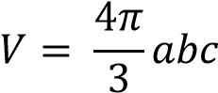

where 𝑎, 𝑏, and 𝑐 are the expected target dimensions in range (m), angle (rad), and doppler (m/s).

For example, consider a vehicle as a radar target. For the vehicle center, we could want to reach +/- 4m in range (𝑎 = 8), +/- 3 degree in azimuth (𝑏 = 6𝜋/180), and +/- 2m/s in radial velocity (𝑐 = 4), resulting in volume about 16.

In addition to setting the volume of the gating ellipsoid, the limits can be imposed to protect ellipsoid from overstretching. The limits are the function of the geometry and motion of the expected targets. For example, setting DepthLimit to 8m will not allow the gating function to stretch beyond 8m in depth.

## Memory Requirements

### 2D Space Tracker

Initial memory footprint for group tracker implementation with 250 measurement points and 20 tracks is approximately 18KB of data and 27KB of program memory for the MSS 2D gtrack application.

#### Data Memory

|  |  |  |  |  |  |
| --- | --- | --- | --- | --- | --- |
| NumTracks | 20 |  |  |  |  |
| NumPoints | 250 |  |  |  |  |
|  | Size, B | Element Name | Element Type | Size | Num |
| TrackModule |  |  |  |  |  |
|  | 424 | inst | GtrackModuleInstance | 424 | 1 |
|  | 144 | inst->params.F | F6 | 144 | 1 |
|  | 144 | inst->params.Q | Q6 | 144 | 1 |
|  | 80 | inst->hTracks | GtrackUnitInstance* | 4 | 20 |
|  | 1000 | inst->bestScore | float | 4 | 250 |
|  | 250 | inst->bestIndex | uint8_t | 1 | 250 |
|  | 32 | Inst->isUniqueIndex | uint8_t | 1 | 32 |
|  | 32 | inst->isStaticIndex | uint8_t | 1 | 32 |
|  | 500 | inst->allocIndexCurrent | uint16_t | 2 | 250 |
|  | 500 | inst->allocIndexStored | uint16_t | 2 | 250 |
|  | 240 | inst->uidElem | GTrack_ListElem | 12 | 20 |
| SubTotal | 3346 |  |  |  |  |
|  |  |  |  |  |  |
| TrackUnit |  |  |  |  |  |
|  | 14720 | inst | GtrackUnitInstance | 736 | 20 |
| SubTotal | 14720 |  |  |  |  |
|  |  |  |  |  |  |
| Total, Bytes | **18066** |  |  |  |  |

#### Program Memory

|  |  |  |  |  |  |  |
| --- | --- | --- | --- | --- | --- | --- |
|  | text | data | bss | dec | hex | filename |
|  | 5366 | 2918 | 0 | 8284 | 205C | gtrack_math.oer5f |
|  | 5278 | 951 | 0 | 6229 | 1855 | gtrack_unit_update.oer5f |
|  | 2478 | 293 | 0 | 2771 | AD3 | gtrack_module.oer5f |
|  | 1882 | 180 | 0 | 2062 | 80E | gtrack_create.oer5f |
|  | 1676 | 36 | 0 | 1712 | 6B0 | gtrack_utilities_2d.oer5f |
|  | 1330 | 0 | 0 | 1330 | 532 | gtrack_utilities.oer5f |
|  | 1020 | 33 | 0 | 1053 | 41D | gtrack_unit_score.oer5f |
|  | 698 | 181 | 0 | 879 | 36F | gtrack_unit_event.oer5f |
|  | 824 | 0 | 0 | 824 | 338 | gtrack_step.oer5f |
|  | 492 | 0 | 0 | 492 | 1EC | gtrack_unit_create.oer5f |
|  | 368 | 124 | 0 | 492 | 1EC | gtrack_unit_predict.oer5f |
|  | 328 | 81 | 0 | 409 | 199 | gtrack_unit_start.oer5f |
|  | 248 | 0 | 0 | 248 | F8 | gtrack_listlib.oer5f |
|  | 228 | 0 | 0 | 228 | E4 | gtrack_delete.oer5f |
|  | 86 | 53 | 0 | 139 | 8B | gtrack_unit_stop.oer5f |
|  | 98 | 0 | 0 | 98 | 62 | gtrack_unit_report.oer5f |
|  | 42 | 0 | 0 | 42 | 2A | gtrack_unit_get.oer5f |
|  | 8 | 0 | 0 | 8 | 8 | gtrack_unit_delete.oer5f |
|  |  |  |  |  |  |  |
| Total | 22450 | 4850 |  | 27300 |  |  |

### 3D Space Tracker

Initial memory footprint for group tracker implementation with 250 measurement points and 20 tracks is approximately 28KB of data and 29KB of program memory for the MSS 3D gtrack application.

#### Data Memory

|  |  |  |  |  |  |
| --- | --- | --- | --- | --- | --- |
| NumTracks | 20 |  |  |  |  |
| NumPoints | 250 |  |  |  |  |
|  | Size, B | Element Name | Element Type | Size | Num |
| TrackModule |  |  |  |  |  |
|  | 424 | inst | GtrackModuleInstance | 424 | 1 |
|  | 324 | inst->params.F | F9 | 324 | 1 |
|  | 324 | inst->params.Q | Q6 | 324 | 1 |
|  | 80 | inst->hTracks | GtrackUnitInstance* | 4 | 20 |
|  | 1000 | inst->bestScore | float | 4 | 250 |
|  | 250 | inst->bestIndex | uint8_t | 1 | 250 |
|  | 32 | Inst->isUniqueIndex | uint8_t | 1 | 32 |
|  | 32 | inst->isStaticIndex | uint8_t | 1 | 32 |
|  | 500 | inst->allocIndexCurrent | uint16_t | 2 | 250 |
|  | 500 | inst->allocIndexStored | uint16_t | 2 | 250 |
|  | 240 | inst->uidElem | GTrack_ListElem | 12 | 20 |
| SubTotal | 3706 |  |  |  |  |
|  |  |  |  |  |  |
| TrackUnit |  |  |  |  |  |
|  | 25120 | inst | GtrackUnitInstance | 1256 | 20 |
| SubTotal | 25120 |  |  |  |  |
|  |  |  |  |  |  |
| Total, Bytes | **28826** |  |  |  |  |

#### Program Memory

|  |  |  |  |  |  |  |
| --- | --- | --- | --- | --- | --- | --- |
|  | text | data | bss | dec | hex | filename |
|  | 5366 | 2918 | 0 | 8284 | 205C | gtrack_math.oer5f |
|  | 5678 | 951 | 0 | 6629 | 19E5 | gtrack_unit_update.oer5f |
|  | 3562 | 52 | 0 | 3614 | E1E | gtrack_utilities_3d.oer5f |
|  | 2542 | 299 | 0 | 2841 | B19 | gtrack_module.oer5f |
|  | 1882 | 180 | 0 | 2062 | 80E | gtrack_create.oer5f |
|  | 1330 | 0 | 0 | 1330 | 532 | gtrack_utilities.oer5f |
|  | 1072 | 33 | 0 | 1105 | 451 | gtrack_unit_score.oer5f |
|  | 698 | 181 | 0 | 879 | 36F | gtrack_unit_event.oer5f |
|  | 872 | 0 | 0 | 872 | 368 | gtrack_step.oer5f |
|  | 384 | 124 | 0 | 508 | 1FC | gtrack_unit_predict.oer5f |
|  | 492 | 0 | 0 | 492 | 1EC | gtrack_unit_create.oer5f |
|  | 352 | 81 | 0 | 433 | 1B1 | gtrack_unit_start.oer5f |
|  | 248 | 0 | 0 | 248 | F8 | gtrack_listlib.oer5f |
|  | 232 | 0 | 0 | 232 | E8 | gtrack_delete.oer5f |
|  | 86 | 53 | 0 | 139 | 8B | gtrack_unit_stop.oer5f |
|  | 126 | 0 | 0 | 126 | 7E | gtrack_unit_report.oer5f |
|  | 56 | 0 | 0 | 56 | 38 | gtrack_unit_get.oer5f |
|  | 8 | 0 | 0 | 8 | 8 | gtrack_unit_delete.oer5f |
|  |  |  |  |  |  |  |
| Total | 24986 | 4872 |  | 29858 |  |  |

* 1. Benchmarks



**Tracking processing cost ≈ 200µs per tracking object**

# Performance

Tracking performance can be intuitively expressed in three classes of metrics:

1. Tracking Reliability, which shows how many mistakes the tracker made in terms of missing tracks, false positives, mismatches, failures to recover tracks, etc.
2. Tracking Precision, which expresses how well exact features of the correctly tracked objects are estimated,
3. Tracking Resolution, which expresses how much feature separation needed between two objects to be tracked separately

## Tracking Reliability

The test case to measure tracking reliability is simulated randomized longevity test. We modeled tracker performance in traffic monitoring usage case.

### Test Case description

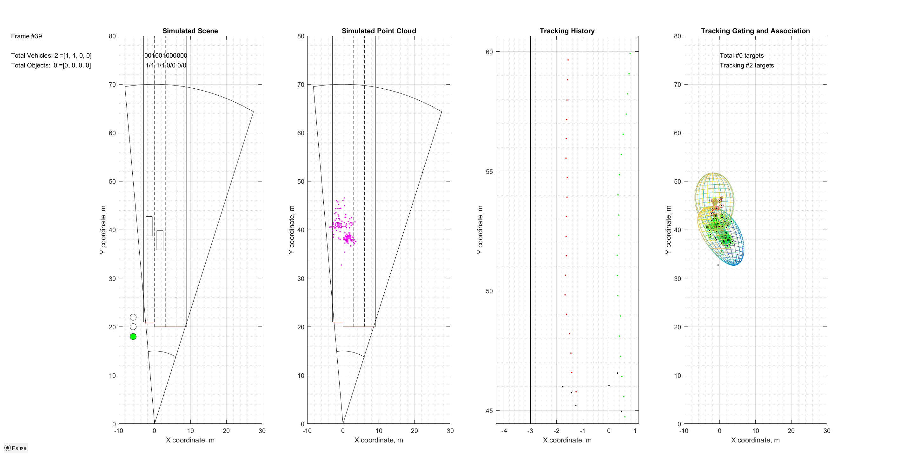The sensor geometry is illustrated in the picture below. Traffic is simulated by random Poisson process, where vehicles arrive into 4-Lane intersection at random velocities. The intersection is controlled by the traffic light with predetermined latencies for green, yellow, and red signals. The stop line is at 20m from the sensor. Vehicles movement is modeled with following rules:

1. Each vehicle maintains constant velocity unless there is an obstacle in front. The obstacle can be another vehicle in front or either red or yellow traffic light.
2. With obstacle in front, the vehicle will decelerate to match the obstacle speed. The amount of deceleration is bounded to a maximum allowed for the given vehicle type.
3. The vehicles preserve a safety 2m distance.
4. Once obstacle cleared, the vehicles accelerate. The acceleration step and maximum amount of acceleration is configured per vehicle type.

The reliability test simulates at least 10 minutes of traffic.

Sensor output (the point cloud) is randomly generated and is modelled after the test data captured from the moving vehicle. The model includes statistical modeling of number of reflection points, points distribution in range/angle space, and distribution of doppler information in a cloud. Each vehicle at any time instance is represented by a point cloud (the set of reflection points with range/angle and radial velocity information).

*Note: Point cloud from multiple vehicles is assumed additive, so we didn’t model the point cloud degradation due to multiple objects.*

For the point cloud synthesis, we collected reflection points from the field test in two detection layer configurations:

* Configuration A, with “maximum possible” reflections (single range CFAR-CASO, no windowing in doppler dimension, 0.2deg DoA step)
* Configuration B, with about 1/3 of reflections (dual pass range/doppler CFAR-CASO, 0.2deg DoA)

The tracker inputs the points cloud, associates reflection points to the tracked objects, predicts, and models the objects behavior, and outputs estimated object properties to an upper layer.

Each configuration is run in two subcases: with

The upper layer processing estimates the tracking error by comparing the ground truth with tracker output. As a ground truth we consider a centroid of the rectangle of simulated vehicle. For each track, based on global time stamp, we synchronize the ground truth point and tracker output. We compute mean square error individually for all time instances the tracker existed. We declare correct tracking of the object if at any point the mean square error did not exceed the desired threshold, and tracking error event otherwise.

In addition, upper layer processing counts number of objects at 25m lane. This count is compared to a ground truth number as well.

### Results

The results are summarized below

#### Configuration A results

|  |  |  |  |  |  |
| --- | --- | --- | --- | --- | --- |
| Lane | Number of Vehicles | Number of Counted objects (at 25m) | Counting Reliability, % | Number of correctly tracked objects | Tracking Reliability, % |
| 1 | 58 | 58 |  | 56 |  |
| 2 | 117 | 122 |  | 110 |  |
| 3 | 177 | 184 |  | 173 |  |
| 4 | 228 | 233 |  | 216 |  |
| Total | 580 | 597 | 99.5 | 555 | 95.7 |

TODO: Due to changes in unrolling functions, the need to Re-run the configuration A tests

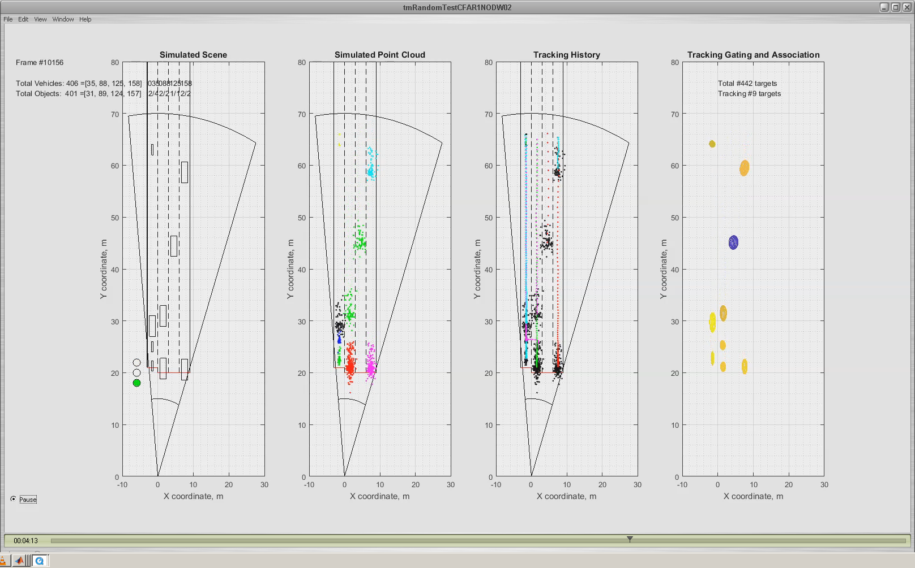

#### Configuration B results

|  |  |  |  |  |  |
| --- | --- | --- | --- | --- | --- |
| Lane | Number of Vehicles | Number of Counted objects (at 25m) | Counting Reliability | Number of correctly tracked objects | Tracking Reliability, % |
| 1 | 61 | 60 |  | 57 |  |
| 2 | 124 | 122 |  | 110 |  |
| 3 | 150 | 147 |  | 126 |  |
| 4 | 211 | 208 |  | 194 |  |
| Total | 546 | 537 | 98.4 | 487 | 89.4 |

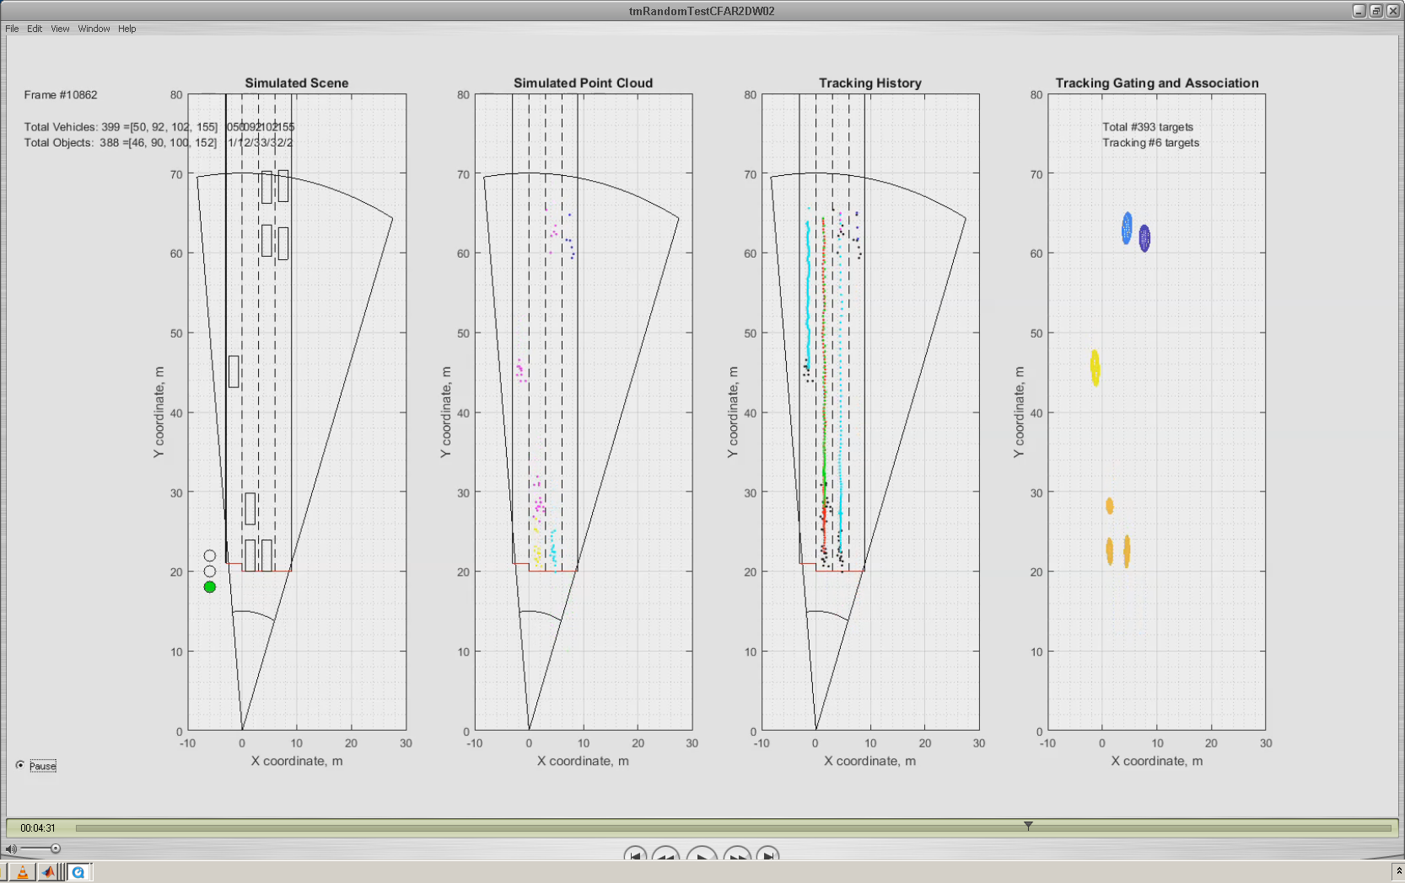

Test is reproducible with this random seed:

Test outputs (the 10-minute movie) is saved here:

The error analysis shows that most of the errors fall into two cases:

1. errors due to erroneous split, i.e. at some time instance the tracker observed too much dispersion within a group, and decided to split a group into two distinct objects
2. errors due to original acquisition, i.e. the track was started with significant deviation from the ground truth, and wasn’t able to converge fast enough

## Tracking Precision

Tracking Precision expresses how well exact features of the correctly tracked objects are estimated. This score is independent of tracker ability to identify and follow the objects. For the correctly tracked object, we compute:

1. Position Tracking Precision. This is the measure of expected positional error (mean and deviation) for matched objects
2. Velocity Tracking Precision. This is the measure of expected velocity error (mean and deviation) for matched objects. Shows the ability of the tracker to estimate object velocity
3. Size Tracking Precision. This is the measure of expected dimensional error (mean and deviation) for matched objects. Shows the ability of the tracker to estimate object size

### Test Case description

For tracking precision, we use the same randomized longevity test case as described above. We take only the “successfully tracked” objects, and derive the error statistics for those cases, comparing the tracked object with the ground truth.

### Results

For successfully tracked objects (95% cases, see the Tracking Reliability Test results), the following was observed:

#### Configuration A results

|  |  |
| --- | --- |
| Tracking Precision  ( % of cases) | Error, Standard Deviation at 40m of Range |
| Latitude (X position), m |  |
| Longitude (Y position), m |  |
| Velocity, Latitudal, m/s |  |
| Velocity, Longtitudal, m/s |  |

#### Configuration B results

|  |  |
| --- | --- |
| Tracking precision  (89.4 % of cases) | Error, Standard Deviation at 40m of Range |
| Latitude (X position), m | 0.11 |
| Longitude (Y position), m | 0.36 |
| Velocity, Latitudal, m/s | 0.99 |
| Velocity, Longtitudal, m/s | 0.4 |

## Tracking Resolution

Tracking Resolution expresses how much of feature separation is needed between two real life objects to be tracked separately. The feature separation can be measured in Range/Angle/Velocity. We designed separate test cases for initial separation, and dynamic (split).

### Initial Separation Tests

#### Test Case description

We designed three separate test cases for Range, Anglular, and radial velocity separation. We simulate the vehicle entry with

1. Range difference (same lane, two vehicles, same velocity, one after each other at given distance),
2. Angle difference (same range, different lanes, same velocity)
3. Velocity difference (adjacent lanes, minimal angular difference, different velocities)

For all tests we are seeking a minimal separation needed for a tracker to allocate and successfully track two objects as separate ones in more than 95% of cases.

#### Results

|  |  |  |  |
| --- | --- | --- | --- |
|  | Test Case Range | Test Case Angle | Test Case Velocity |
| Range Difference, m | 4 | 0 | 0 |
| Angular Separation, deg | 0 | 4 | 0 |
| Radial Velocity, m/s | 0 | 0 | 4 |
| Test Success Rate | >95% | >95% | >95% |

### Dynamic Separation Tests

#### Test Case description

Separate test is designed, where at entrance, two objects are not distinguishable. The tracker shall allocate a single tracking object. However, due to velocity difference, after few tens of frames, tracker shall be able to trigger a split event and track two targets. We measure the amount of separation required (in Range AND Angle AND Velocity) when tracker performs split in >95% cases.

#### Results

|  |  |
| --- | --- |
|  | Test Case Split |
| Range Difference, m | 4 |
| Angular Separation, deg | 4 |
| Radial Velocity, m/s | 4 |
| Test Success Rate | >95% |

# References

[1] <https://github.com/rlabbe/Kalman-and-Bayesian-Filters-in-Python>

[2] Samuel S. Blackman. Multi-Target Tracking with Radar Applications, Artech House, 1986

[3] Muhammad Ikram, Nano radar DSP Algorithm Module, Tracking module description

# Appendix

## Evaluating Partial Derivatives for 2D space tracking

We need to calculate set of partial derivatives to compute Jacobian

### Evaluating range partial derivatives

### Evaluating azimuth partial derivatives

Let with

Using the chain rule:

Using the chain rule:

### Evaluating doppler partial derivatives

Using the quotient rule , solving the first part .

For the second part, .

Similarly,

Putting all together:

## Evaluating Partial Derivatives for 3D space tracking

We need to calculate set of partial derivatives to compute Jacobians for 3DV and 3DA models:

and

### Evaluating range partial derivatives

### Evaluating azimuth partial derivatives

Let with

Using the chain rule:

Using the chain rule:

### Evaluating elevation partial derivatives

Let with

Using the chain rule:

Using the chain rule:

Using the chain rule:

### Evaluating Doppler partial derivatives

Using the quotient rule , solving

Using chain rule,

Due to symmetry:

Putting all together:

where .

* 1. Orthogonal projection of an Ellipsoid E onto a given line

We consider a given line , parameterized by a scalar s, deﬁned by

where is a given point and is a given non-zero vector, see Figure 9.

Given any point in the space, based on orthogonality of and its orthogonal projection onto corresponds to

Figure . The orthogonal projection of the ellipsoid E onto the line is the interval [S-, S+],

Now, the ellipsoid E is given by

Thus the projection of points in E correspond to values of s

where

Given the condition, it is evident that the orthogonal projection of onto corresponds to the interval with

And the projection length is

The projections onto orthogonal axes